Supplementary Table 1: Outcomes associated with post-discharge ACEI/ARB use

|  |  |  |  |  |  |
| --- | --- | --- | --- | --- | --- |
|  | **No. of Events/**  **No. of Patients** | **Hazard ratio (95% confidence interval)** | | | |
| **Crude** | **p-Value** | **Adjusted**\* | **p-Value** |
| **ESRD**  Nonusers  ACEI/ARB users | 1225/8463  1277/8463 | 1 [Reference]  1.00 (0.93–1.07) | 0.96 | 1 [Reference]  0.95 (0.88–1.02) | 0.14 |

Supplementary Table 2: Outcomes associated with continued use, prior use, and new use of ACEI/ARB

|  |  |  |  |
| --- | --- | --- | --- |
| **ACEI/ARB use** | **No. of Events/**  **No. of Patients** | **Adjusted hazard ratio (95% confidence interval)** * | **p-Value** |
| **ESRD**  Nonuser  Continued use  Prior use  New use | 501/3752  781/4774  756/4711  464/3689 | 1 [Reference]  0.90 (0.81–1.00)  0.99 (0.92–1.05)  0.96 (0.90–1.03) | 0.05  0.67  0.26 |

Supplementary Table 3: Outcomes associated with post-discharge ACEI/ARB use for ≥ 28 days

|  |  |  |  |  |  |  |  |
| --- | --- | --- | --- | --- | --- | --- | --- |
|  | **Events** | **Person-years** | **Incidence rate (per 1,000 person-years)** | **Hazard ratio (95% confidence interval)** | | | |
| **Crude** | **p-Value** | **Adjusted**\* | **p-Value** |
| **All-cause mortality**  Nonusers  ACEI/ARB users | 3,101  2,572 | 252,344  221,126 | 12.29  11.63 | 1 [Reference]  0.86 (0.81–0.90) | < 0.001 | 1 [Reference]  0.94 (0.90–0.99) | 0.02 |
| **ESRD**  Nonusers  ACEI/ARB users | 1,512  1,468 | 226,723  214,795 | 6.67  6.83 | 1 [Reference]  0.96 (0.90–1.03) | 0.53 | 1 [Reference]  1.02 (0.94–1.11) | 0.66 |

Supplementary Figure 1: Kaplan-Meier curves for long-term event-free survivals in patients whose post-discharge prescription of ACEI/ARB was ≥ 28 days.

1. All-cause death

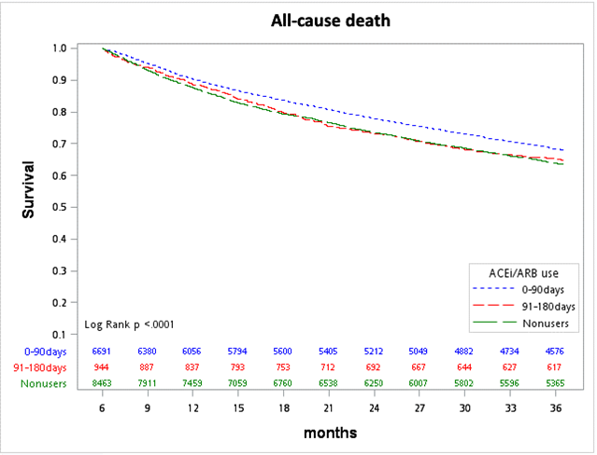

1. ESRD

