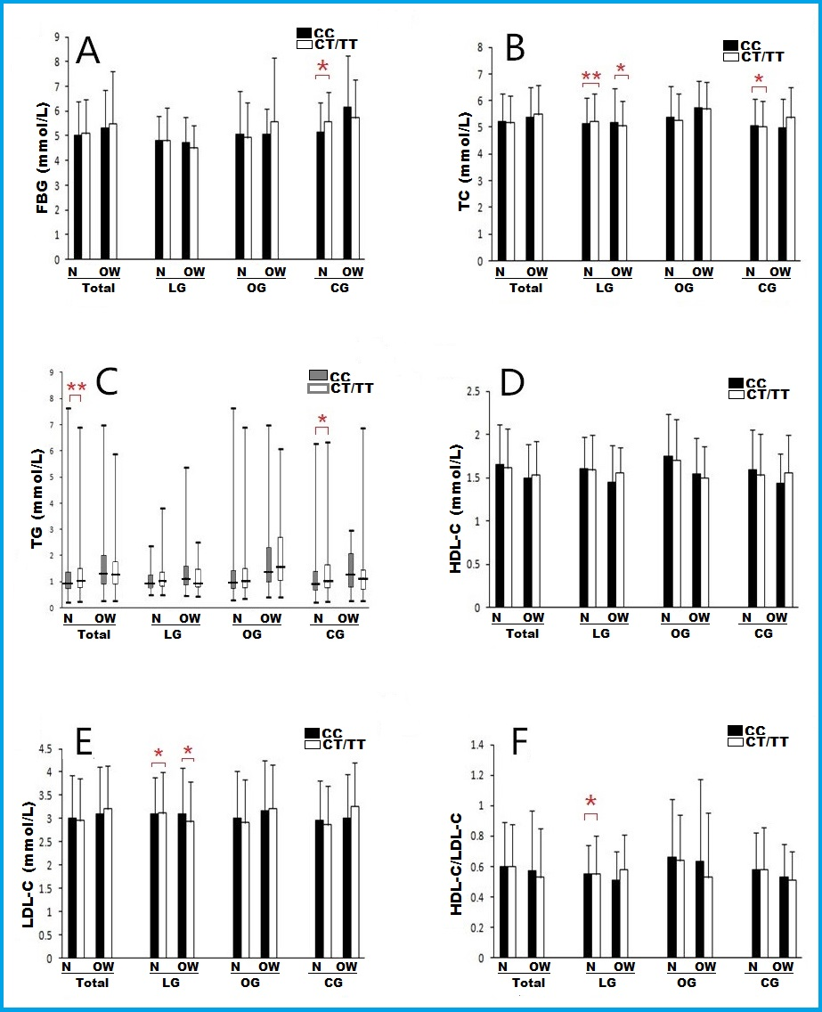

Figure S1 Association between GHSR rs572169 genotypes and metabolic risks after stratification by BMI status. N, normal; OW, overweight; * and ** indicate P < 0.05, P < 0.01, respectively. Other notes and abbreviations see legends of Figure 2.

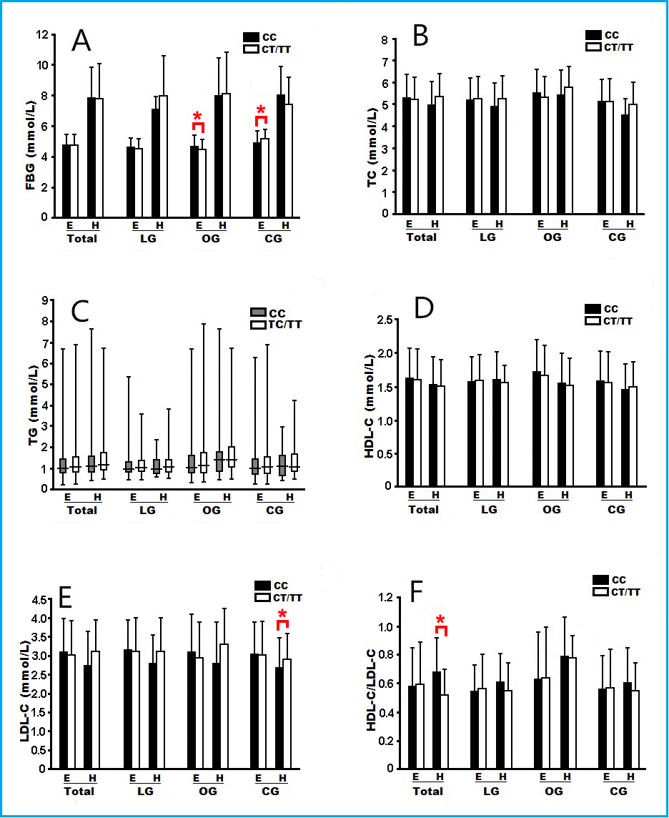

Figure S2 Association between GHSR rs572169 genotypes and metabolic risks after stratification by FBG status. E, euglycaemia; H, hyperglyceamia. * and ** indicate P < 0.05, P < 0.01, respectively. Other notes and abbreviations see legends of Figure 2.
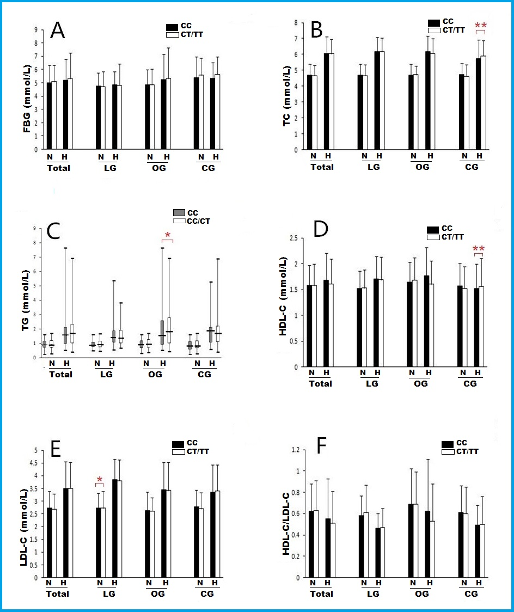

Figure S3 Association between GHSR rs572169 genotypes and metabolic risks after stratification by lipid status. H, hyperlipidemia; N, normolipidemia. * and ** indicate P < 0.05, P < 0.01, respectively. Other notes and abbreviations see legends of Figure 2.

 | Table S1 Correlation analyses between metabolic parameters and GHSR rs572169 genotypes
Parameter |  | Relative factor | Unstandardized Coefficients |  |  |  | Standardized Coefficients |  |  |  | t |  |  | P |  | 95% Confidence interval for B
 |  |  | B |  |  | Std. Error | Beta |  |  |  |  |  |  |  | Lower Bound |  |  | Upper Bound
LG
FBG |  | TG | 0.272 |  | 0.103 |  |  | 0.117 | 2.624 |  |  | 0.009 |  |  |  |  | 0.068 |  |  | 0.475
TC |  | LDL | 0.942 |  | 0.015 |  |  | 0.789 | 63.881 |  |  | 0.000 |  |  |  |  | 0.913 |  |  | 0.971
 |  | HDL | 0.935 |  | 0.032 |  |  | 0.350 | 28.807 |  |  | 0.000 |  |  |  |  | 0.871 |  |  | 0.999
 |  | TG | 0.442 |  | 0.026 |  |  | 0.219 | 17.308 |  |  | 0.000 |  |  |  |  | 0.392 |  |  | 0.492
 |  | WC | 0.003 |  | 0.001 |  |  | 0.026 | 2.205 |  |  | 0.028 |  |  |  |  | 0.000 |  |  | 0.005
TG |  | TC | 0.832 |  | 0.049 |  |  | 1.683 | 17.158 |  |  | 0.000 |  |  |  |  | 0.737 |  |  | 0.927
 |  | HDL | -1.138 |  | 0.086 |  |  | -0.863 | -13.177 |  |  | 0.000 |  |  |  |  | -1.308 |  |  | -0.968
 |  | LDL | -0.600 |  | 0.062 |  |  | -1.016 | -9.731 |  |  | 0.000 |  |  |  |  | -0.721 |  |  | -0.479
 |  | FBG | 0.031 |  | 0.014 |  |  | 0.071 | 2.195 |  |  | 0.029 |  |  |  |  | 0.003 |  |  | 0.058
 |  | HDL/LDL | 0.407 |  | 0.172 |  |  | 0.177 | 2.371 |  |  | 0.018 |  |  |  |  | 0.070 |  |  | 0.745
 |  | Weight | 0.007 |  | 0.002 |  |  | 0.108 | 3.046 |  |  | 0.002 |  |  |  |  | 0.003 |  |  | 0.012
 |  | Sex | 0.125 |  | 0.043 |  |  | 0.101 | 2.868 |  |  | 0.004 |  |  |  |  | 0.039 |  |  | 0.210
HDL |  | HDL/LDL | 1.186 |  | 0.056 |  |  | 0.682 | 21.133 |  |  | 0.000 |  |  |  |  | 1.076 |  |  | 1.297
 |  | TC | 0.382 |  | 0.022 |  |  | 1.020 | 17.692 |  |  | 0.000 |  |  |  |  | 0.340 |  |  | 0.425
 |  | TG | -0.226 |  | 0.017 |  |  | -0.299 | -13.098 |  |  | 0.000 |  |  |  |  | -0.260 |  |  | -0.192
 |  | LDL | -0.111 |  | 0.030 |  |  | -0.248 | -3.717 |  |  | 0.000 |  |  |  |  | -0.170 |  |  | -0.052
 |  | Weight | -0.002 |  | 0.001 |  |  | -0.043 | -2.204 |  |  | 0.028 |  |  |  |  | -0.004 |  |  | 0.000
LDL |  | TC | 0.671 |  | 0.012 |  |  | 0.801 | 55.293 |  |  | 0.000 |  |  |  |  | 0.647 |  |  | 0.695
 |  | HDL/LDL | -1.424 |  | 0.055 |  |  | -0.366 | -25.705 |  |  | 0.000 |  |  |  |  | -1.533 |  |  | -1.315
 |  | TG | -0.219 |  | 0.024 |  |  | -0.130 | -9.243 |  |  | 0.000 |  |  |  |  | -0.266 |  |  | -0.173
HDL/LDL |  | LDL | -0.401 |  | 0.016 |  |  | -1.562 | -25.708 |  |  | 0.000 |  |  |  |  | -0.432 |  |  | -0.371
 |  | TC | 0.239 |  | 0.014 |  |  | 1.108 | 17.675 |  |  | 0.000 |  |  |  |  | 0.212 |  |  | 0.265
 |  | TG | -0.125 |  | 0.012 |  |  | -0.286 | -10.026 |  |  | 0.000 |  |  |  |  | -0.149 |  |  | -0.100
OG
FBG |  | WC | 0.043 |  | 0.007 |  |  | 0.242 | 6.375 |  |  | 0.000 |  |  |  |  | 0.030 |  |  | 0.056
 |  | HDL | -0.311 |  | 0.144 |  |  | -0.083 | -2.158 |  |  | 0.031 |  |  |  |  | -0.593 |  |  | -0.028
 |  | Age | 0.034 |  | 0.008 |  |  | 0.152 | 3.988 |  |  | 0.000 |  |  |  |  | 0.017 |  |  | 0.050
 |  | Sex | 0.357 |  | 0.135 |  |  | 0.095 | 2.653 |  |  | 0.008 |  |  |  |  | 0.093 |  |  | 0.621
 |  | SBP | -0.007 |  | 0.003 |  |  | -0.096 | -2.414 |  |  | 0.016 |  |  |  |  | -0.013 |  |  | -0.001
 |  | TG | 0.105 |  | 0.037 |  |  | 0.111 | 2.856 |  |  | 0.004 |  |  |  |  | 0.033 |  |  | 0.178
TC |  | LDL | 1.161 |  | 0.023 |  |  | 1.072 | 50.589 |  |  | 0.000 |  |  |  |  | 1.116 |  |  | 1.206
 |  | TG | 0.251 |  | 0.010 |  |  | 0.434 | 26.164 |  |  | 0.000 |  |  |  |  | 0.232 |  |  | 0.270
 |  | HDL/LDL | 0.893 |  | 0.059 |  |  | 0.315 | 15.078 |  |  | 0.000 |  |  |  |  | 0.777 |  |  | 1.009
 |  | Height | -0.007 |  | 0.002 |  |  | -0.049 | -3.053 |  |  | 0.002 |  |  |  |  | -0.011 |  |  | -0.002
 |  | DBP | 0.004 |  | 0.002 |  |  | 0.038 | 2.396 |  |  | 0.017 |  |  |  |  | 0.001 |  |  | 0.007
TG |  | LDL | -2.415 |  | 0.099 |  |  | -1.290 | -24.294 |  |  | 0.000 |  |  |  |  | -2.610 |  |  | -2.219
 |  | TC | 1.862 |  | 0.074 |  |  | 1.077 | 25.176 |  |  | 0.000 |  |  |  |  | 1.717 |  |  | 2.007
 |  | HDL/LDL | -1.491 |  | 0.177 |  |  | -0.305 | -8.405 |  |  | 0.000 |  |  |  |  | -1.839 |  |  | -1.142
 |  | CC | 0.026 |  | 0.008 |  |  | 0.097 | 3.285 |  |  | 0.001 |  |  |  |  | 0.011 |  |  | 0.042
 |  | FBG | 0.096 |  | 0.027 |  |  | 0.091 | 3.551 |  |  | 0.000 |  |  |  |  | 0.043 |  |  | 0.150
 |  | Height | 0.016 |  | 0.007 |  |  | 0.067 | 2.349 |  |  | 0.019 |  |  |  |  | 0.003 |  |  | 0.029
HDL |  | TG | -0.214 |  | 0.008 |  |  | -0.842 | -25.295 |  |  | 0.000 |  |  |  |  | -0.231 |  |  | -0.198
 |  | HDL/LDL | 0.429 |  | 0.043 |  |  | 0.345 | 10.039 |  |  | 0.000 |  |  |  |  | 0.345 |  |  | 0.513
 |  | TC | 0.457 |  | 0.023 |  |  | 1.038 | 19.615 |  |  | 0.000 |  |  |  |  | 0.411 |  |  | 0.502
 |  | LDL | -0.321 |  | 0.031 |  |  | -0.673 | -10.417 |  |  | 0.000 |  |  |  |  | -0.381 |  |  | -0.260
 |  | BMI | -0.017 |  | 0.003 |  |  | -0.119 | -5.009 |  |  | 0.000 |  |  |  |  | -0.024 |  |  | -0.011
 |  | FBG | -0.013 |  | 0.006 |  |  | -0.048 | -2.038 |  |  | 0.042 |  |  |  |  | -0.025 |  |  | 0.000
LDL |  | TC | 0.764 |  | 0.015 |  |  | 0.827 | 50.344 |  |  | 0.000 |  |  |  |  | 0.734 |  |  | 0.793
 |  | HDL/LDL | -0.645 |  | 0.045 |  |  | -0.247 | -14.230 |  |  | 0.000 |  |  |  |  | -0.734 |  |  | -0.556
 |  | TG | -0.250 |  | 0.009 |  |  | -0.467 | -26.748 |  |  | 0.000 |  |  |  |  | -0.268 |  |  | -0.231
 |  | HDL | -0.414 |  | 0.038 |  |  | -0.198 | -10.819 |  |  | 0.000 |  |  |  |  | -0.490 |  |  | -0.339
HDL/LDL |  | LDL | -0.361 |  | 0.014 |  |  | -0.943 | -26.465 |  |  | 0.000 |  |  |  |  | -0.388 |  |  | -0.334
 |  | HDL | 0.272 |  | 0.020 |  |  | 0.339 | 13.822 |  |  | 0.000 |  |  |  |  | 0.233 |  |  | 0.310
 |  | TC | 0.119 |  | 0.013 |  |  | 0.338 | 9.105 |  |  | 0.000 |  |  |  |  | 0.094 |  |  | 0.145
 |  | CC | 0.003 |  | 0.001 |  |  | 0.054 | 2.218 |  |  | 0.027 |  |  |  |  | 0.000 |  |  | 0.006
CG
FBG |  | PP | 0.020 |  | 0.003 |  |  | 0.251 | 6.482 |  |  | 0.000 |  |  |  |  | 0.014 |  |  | 0.026
 |  | BMI | 0.105 |  | 0.024 |  |  | 0.221 | 4.451 |  |  | 0.000 |  |  |  |  | 0.059 |  |  | 0.152
 |  | DBP | -0.014 |  | 0.004 |  |  | -0.133 | -3.448 |  |  | 0.001 |  |  |  |  | -0.022 |  |  | -0.006
 |  | TC | -0.164 |  | 0.050 |  |  | -0.123 | -3.268 |  |  | 0.001 |  |  |  |  | -0.263 |  |  | -0.066
 |  | CC | -0.020 |  | 0.010 |  |  | -0.100 | -2.021 |  |  | 0.044 |  |  |  |  | -0.039 |  |  | -0.001
TC |  | LDL | 0.937 |  | 0.014 |  |  | 0.798 | 66.524 |  |  | 0.000 |  |  |  |  | 0.910 |  |  | 0.965
 |  | TG | 0.440 |  | 0.011 |  |  | 0.495 | 40.636 |  |  | 0.000 |  |  |  |  | 0.419 |  |  | 0.462
 |  | HDL | 0.951 |  | 0.027 |  |  | 0.429 | 34.873 |  |  | 0.000 |  |  |  |  | 0.897 |  |  | 1.004
 |  | FBG | -0.029 |  | 0.009 |  |  | -0.039 | -3.337 |  |  | 0.001 |  |  |  |  | -0.046 |  |  | -0.012
 |  | Sex | 0.072 |  | 0.025 |  |  | 0.034 | 2.854 |  |  | 0.004 |  |  |  |  | 0.022 |  |  | 0.121
TG |  | HDL | -1.769 |  | 0.057 |  |  | -0.710 | -30.923 |  |  | 0.000 |  |  |  |  | -1.881 |  |  | -1.656
 |  | TC | 1.662 |  | 0.041 |  |  | 1.480 | 40.636 |  |  | 0.000 |  |  |  |  | 1.582 |  |  | 1.742
 |  | LDL | -1.591 |  | 0.045 |  |  | -1.206 | -35.175 |  |  | 0.000 |  |  |  |  | -1.680 |  |  | -1.502
 |  | Sex | -0.161 |  | 0.049 |  |  | -0.068 | -3.306 |  |  | 0.001 |  |  |  |  | -0.257 |  |  | -0.065
 |  | FBG | 0.045 |  | 0.017 |  |  | 0.054 | 2.649 |  |  | 0.008 |  |  |  |  | 0.012 |  |  | 0.079
HDL |  | HDL/LDL | 1.250 |  | 0.054 |  |  | 0.683 | 23.076 |  |  | 0.000 |  |  |  |  | 1.143 |  |  | 1.356
 |  | LDL | -0.106 |  | 0.029 |  |  | -0.201 | -3.706 |  |  | 0.000 |  |  |  |  | -0.162 |  |  | -0.050
 |  | TC | 0.381 |  | 0.020 |  |  | 0.845 | 19.071 |  |  | 0.000 |  |  |  |  | 0.342 |  |  | 0.420
 |  | TG | -0.188 |  | 0.011 |  |  | -0.468 | -17.735 |  |  | 0.000 |  |  |  |  | -0.209 |  |  | -0.167
 |  | Sex | -0.033 |  | 0.016 |  |  | -0.035 | -2.070 |  |  | 0.039 |  |  |  |  | -0.064 |  |  | -0.002
LDL |  | TC | 0.700 |  | 0.021 |  |  | 0.822 | 33.949 |  |  | 0.000 |  |  |  |  | 0.660 |  |  | 0.741
 |  | HDL/LDL | -1.232 |  | 0.091 |  |  | -0.356 | -13.586 |  |  | 0.000 |  |  |  |  | -1.410 |  |  | -1.054
 |  | TG | -0.313 |  | 0.013 |  |  | -0.413 | -24.396 |  |  | 0.000 |  |  |  |  | -0.339 |  |  | -0.288
 |  | HDL | -0.201 |  | 0.056 |  |  | -0.106 | -3.585 |  |  | 0.000 |  |  |  |  | -0.311 |  |  | -0.091
 |  | WC | 0.004 |  | 0.001 |  |  | 0.033 | 2.778 |  |  | 0.006 |  |  |  |  | 0.001 |  |  | 0.006
HDL/LDL |  | LDL | -0.198 |  | 0.005 |  |  | -0.683 | -42.153 |  |  | 0.000 |  |  |  |  | -0.207 |  |  | -0.188
 |  | HDL | 0.369 |  | 0.009 |  |  | 0.675 | 41.689 |  |  | 0.000 |  |  |  |  | 0.352 |  |  | 0.386
Abbreviations: BMI, body mass index; CC, chest circumference; CG, control group; DBP, diastolic blood pressure; FPG fasting plasma glucose; HDL-C, high-density lipoprotein cholesterol; LDL-C, low-density lipoprotein cholesterol; LG, long-lived group; OG, offspring group; PP, pulse pressure; SBP, systolic blood pressure; TC, total cholesterol; TG, triglyceride; WC, waist circumference.

