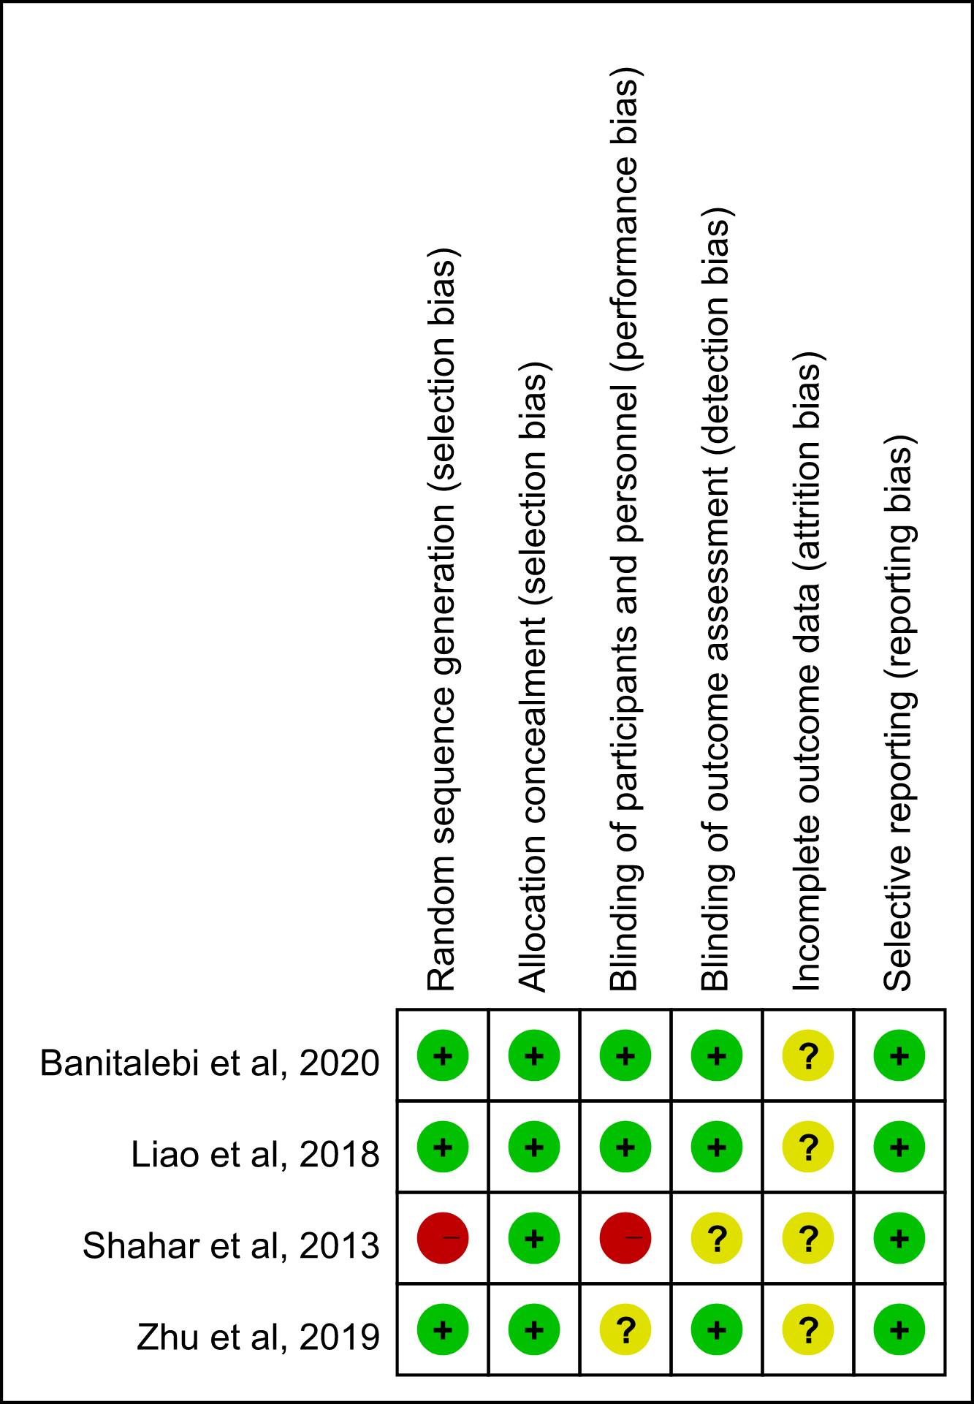
Supplemental Figure 1. Risk of bias summary elastic band.
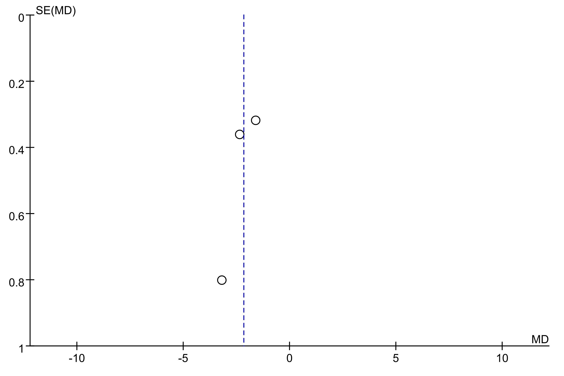
Supplemental Figure 2. Funnel plot.

